Name: ____________________________________________________________ Date: ________________________

**Unit 2 – Study Guide 2**

**Find the solution of the linear system graphically. Write your solution in the blank provided.**

**_______**1.  _______2.

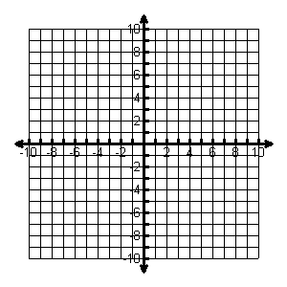 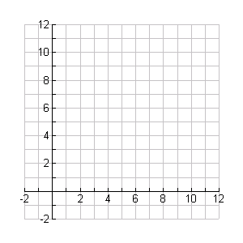

**Use substitution to solve the linear system. SHOW ALL WORK and write your solution in the space provided.**

________3.  _______4.

**Use elimination to solve the linear system. SHOW ALL WORK and write your solution in the space provided.**

________5.  _______6.

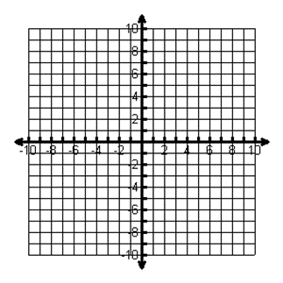

**Use any method to solve the linear system. SHOW ALL WORK and write your solution in the space provided.**

________7. 

**Systems of Linear Equations Word Problems:**

8. Bill wants to buy some CDs at the music store. Used ones sell for $4.99, and new ones sell for $13.99. He has $75 to spend that he got for his birthday.

a) Write a linear inequality to represent the situation. Can Bill by 4 used and 4 new CDs?

9. A store sold 32 pairs of jeans for a total of $1050. Brand A sold for $30 per pair and Brand B sold for $35 per pair. How many of Brand A were sold?

10. You are selling tickets for a basketball game. Student tickets cost $3 and general admission tickets cost $5. You sell 350 tickets and collect $1450. How many of each type of ticket did you sell?

**Graph the systems of inequalities, and name a solution.**

________11.  _______12.



**Systems of Linear Inequalities Word Problems:**

13. Julia and Jackson are raising money for a Mother’s Day gift. They have a lemonade stand and are selling cups of lemonade for $2 each and cookies for $1.50 each. They must raise at least $150.

* 1. Write an inequality to express the income from the lemonade stand.
  2. They expect to sell at least 3 dozen cookies. Write an inequality to represent this situation.

14. You are looking to buy a bouquet of flowers for your favorite math teacher. Lilies cost $3.00 each and roses cost $4.00 each. You have budgeted no more than $28 to spend on flowers. Graph a system of inequalities to illustrate how many of each type of flower you can purchase if you want to buy at least half a dozen flowers. Explain how to use the graph to determine possible solutions.

