**GSE Algebra Name _______________________________**

**Review Unit 1C Form A**

**For problems, simplify the following expressions. Write the answers in standard form.**

1. 2.

3. 4.

5. 6.

7.

8. Identify the following, given the polynomial: $-6x^{4}-x^{3}+7$

How many terms? ____________ What is the constant? __________

What are the coefficients: ______________ What is the degree? _________

9. Create a polynomial that has 4 terms, with a degree of 6, and a leading coefficient of 2.

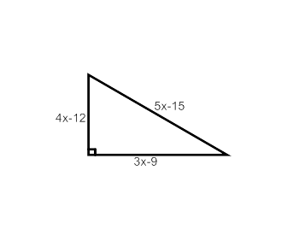

10. Use the given triangle to find the following:

a. Perimeter

b. Area

11. Consider the polynomial.

Write the polynomial in standard form. ________________________

What is the degree of the polynomial? ________________________

What is the leading coefficient? ________________________

Classify the polynomial according to the number of terms. ________________________

12.Give the perimeter of the deck shown below.

x +3

x +3

10

2x + 4

13. Find the area of the figures

1. b)

x+3

x+2

2x+6

4x+2

14.Find the area of the white space.

(*x* + 2)

*x*

(*x* + 3)

2*x*

1. Find the volume of the rectangular prism.

x +3

x +1

x +6

Add or Subtract:

1. 
2. 

# Multiply:

1. 
2. 
3. 
4. 