Scatter Plots, Correlation, and Causation
Scatter Plot:__________________________________________________________________
______________________________________________________________________________
______________________________________________________________________________
Example: This scatterplot describes the relationship between minutes studying and score on a test. As the time spent studying increases, the test scores increase.
Graph the points and answer the question.
What would you predict is the test score for someone who spends 10 minutes studying?
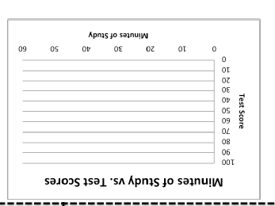
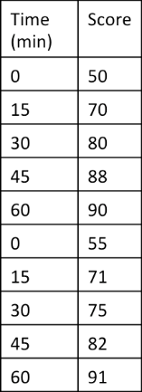

Correlation: _________________________________________________________________
______________________________________________________________________________
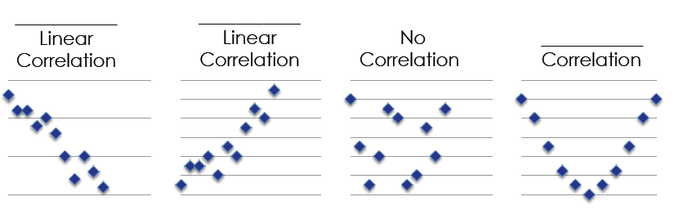

We can measure correlation coefficient, or the R-value. The correlation coefficient is always between -1 and 1, and tells us how close the scatter plot is forming a straight line.
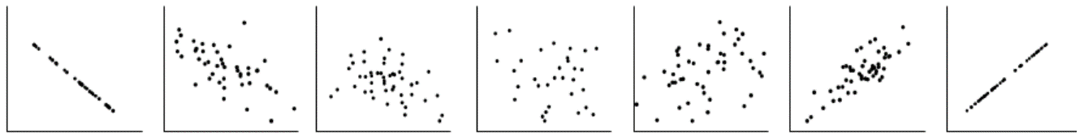

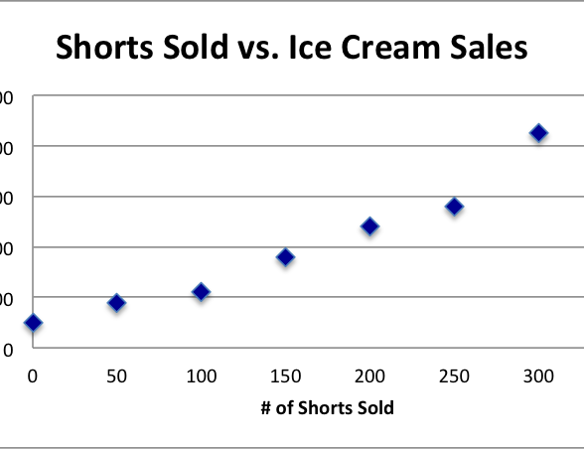
“Correlation does __________imply ___________________””, is a common phrase in stats. It means correlation is not causation. Just because there is a _______________________, it does not mean it is the cause.

Estimate the Correlation Coefficent? ____________
Is there Causation? ____________________________

Examples of Correlation or Causation?
- The age of a child and their shoe size.
______________________________
- The number of cars on the road and the number of accidents reported.
_______________________________
- The number of salles made and the amount of commission earned.
________________________________
- A child’s weight and the size of her vocabulary.
_________________________________
- The number of miles drive and the amount of gas used.
_________________________________

