Name: _____________________________________________ Date: ________________________

**Unit 2 Test**

**Determine whether the relation is a function. Write function or relation and explain how you know.**

1.

0

16

-4

0

4

2. $\left\{\left(-2,1\right), \left(3,4\right), (-2,4)\right\}$

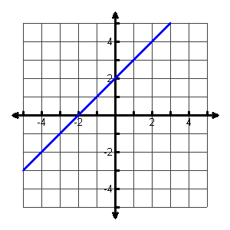

3.

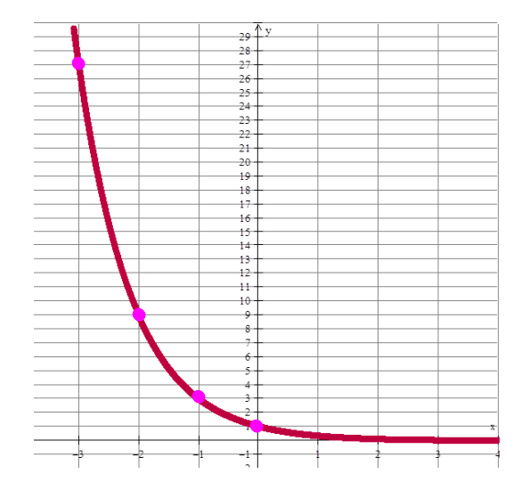

**Evaluation Functions:**

4. f(0) = _____

5. f(-2) = _____

6. If f(x) = 27, then x = __________

**Function Notation.**

Evaluate the functions given below if 

7.  8. g(-2)

9. f(x) – g(x) 10. f(2) + g(1)

11. 7f(x)

12. What is the domain and range of the function below?

|  |  |  |  |
| --- | --- | --- | --- |
| X | 1 | 2 | 3 |
| Y | -2 | -3 | -6 |

Domain:_______________________

Range: ________________________

1. If  and , what is ?



* 1. 11
  2. 10
  3. 20
  4. 19

1. Write the recursive and explicit formula for the following sequence:

5, 10, 15, 20, …

Recursive ______________________ Explicit _____________________

12, 9, 6, 3, …

Recursvie _______________________ Explicit ___________________

Use the functions below to answer the questions.

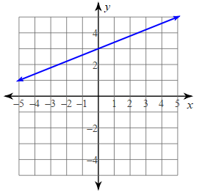Function A Function B

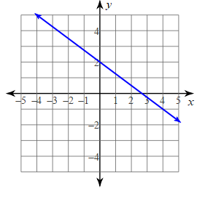

|  |  |
| --- | --- |
| 15. Which function is decreasing? | ___________________ |
| 16. Which function is increasing? | ___________________ |
| 17. Which function has an y intercept of (0, 3)? | ___________________ |
| 18. Which function has an x intercept of (3, 0)? | ___________________ |
| 19. Which function has the end behavior:  As x 🡪 ∞, y🡪 + ∞  As x 🡪 -∞, y🡪 -∞ | ___________________ |
| 20. Which function has the end behavior:  As x 🡪 ∞, y🡪 -∞  As x 🡪 -∞, y🡪 +∞ | ___________________ |
| 21. What is the y-intercept of function A? | ___________________ |
| 22. What is the y-intercept of function B? | ___________________ |
| 23. What is the domain of the functions? | ___________________ |
| 24. What is the range of the functions? | ___________________ |