Line of Best Fit Notes
Line of Best Fit: ____________________________________________________________________________________________________________________________________________________________________________________________________________________________________________________________________________________________________________________________________________________
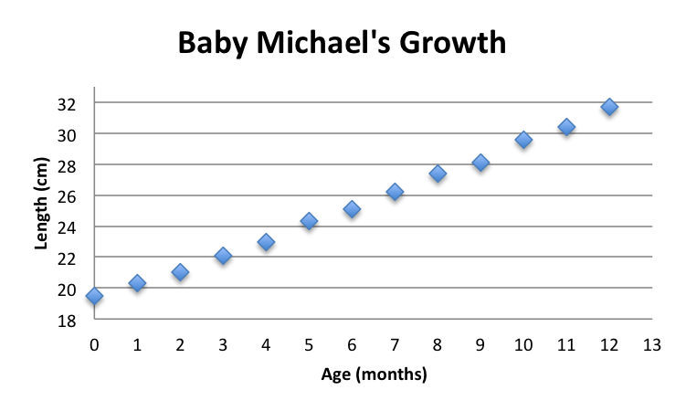
The scatter plot show the line of best fit.
- How would you describe the correlation?
- Estimate the r-value.
- What does the slope and y-intercept
represent?
Example
Number of CD’s Sold
Fill in x-y table
X | Y

1. Draw the line of best fit.
2. Determine the equation for your line of best fit by using technology
3. What is the r-value? How would you describe the data?
4. Discuss what the slope and y-intercept represent?
5. Use your equation to predict the number of CD sales in 2018.

