Name:_Keyshawn Johnson___ Class __FOA___ Date _9/6/19___

Coordinate Plane Quiz

**I. Vocabulary** (Fill in the blank)

|  |
| --- |
| Origin X-Coordinate Y-Coordinate X-Axis Y- Axis Quadrant Ordered Pair |

1.) The four regions on the coordinate plane are called __Quadrants______.

2.) The Y-Coordinate corresponds to a number on the y-axis.

3.) The X-Coordinate corresponds to a number on the x – axis.

4.) The vertical number line is called the _Y-Axis_.

5.) The point where the number lines intersect is called the Origin.

6.) The horizontal number line is called the X-Axis.

7.) A(n) Ordered Pair is the set of numbers used to locate a   
 point on the coordinate plane.

**II. Name the Quadrant**8.) Label the quadrants on the coordinate plane below, and then write the quadrant (or axis) where each point would lie in the coordinate plane.

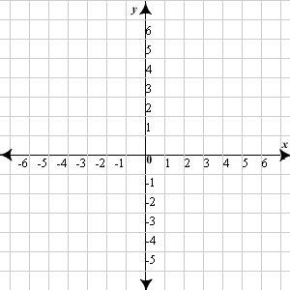

Ordered Pair Quadrant  
9.) (-4, -3) 3 or III

10.) (1, 6) 1 or I

11.) (-2, 0) ?

12.) (5, -5) 4 or IV

13.) (0, 4) ?

**III. Graph and Label the Ordered Pairs**

Plot each point on the coordinate plane. Label with the corresponding letter.





14.) **A** (-4, -5)

15.) **B** (6, -5)

16.) **C** (-2, 0)

17.) **D** (6, 5)

18.) **E** (-4, 5)

19.) **F** (0, 5)

**IV. List the Ordered Pairs**



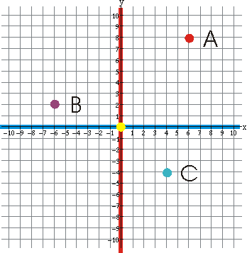



Write the ordered pair for each point:

20.) **A** __(6,8)__

21.) **B** (-6 , 2)

22.) **C** (4, -4)

**V. Graphing Linear Equations in Slope-Intercept Form**

Graph each line on the graph provided.

23.)  24.) 





25.)  26.) 





Find the slope of the line given a graph.

27. 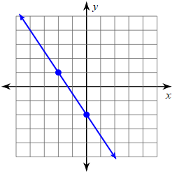 28. 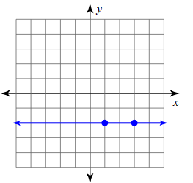

**0**

29. 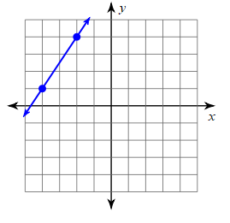 30. 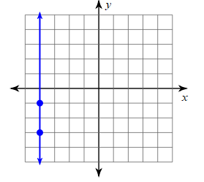

**Undefined**